SET 14 – SURVEY RESULTS
respondent <- 1:3
q1 <- c("A","B","C")
q2 <- c("B","A","D")
q3 <- c("C","A","B")

survey <- rbind(table(q1),table(q2),table(q3))

barplot(survey,
beside=FALSE,
col=rainbow(4),
legend=rownames(survey),
main="Survey Responses",
xlab="Questions",
ylab="Count")

install.packages("fmsb")
library(fmsb)

radar <- data.frame(
A=c(3,1,2),
B=c(3,2,1),
C=c(3,1,1),
D=c(3,0,1)
)

radarchart(radar)

survey_table <- data.frame(
Respondent=respondent,
Question1=q1,
Question2=q2,
Question3=q3
)

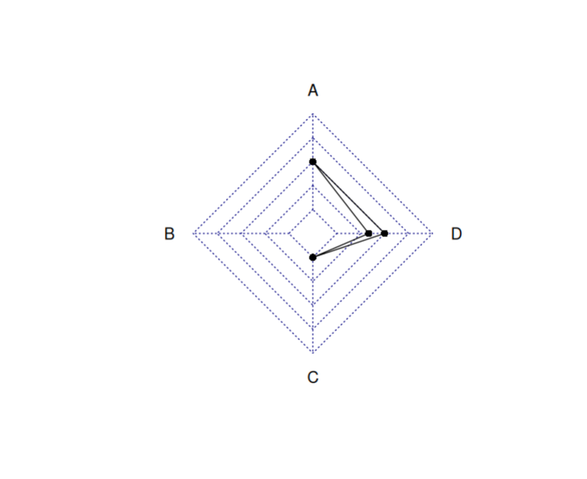
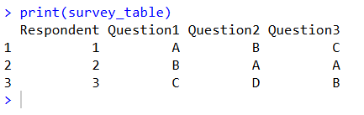
print(survey_table)
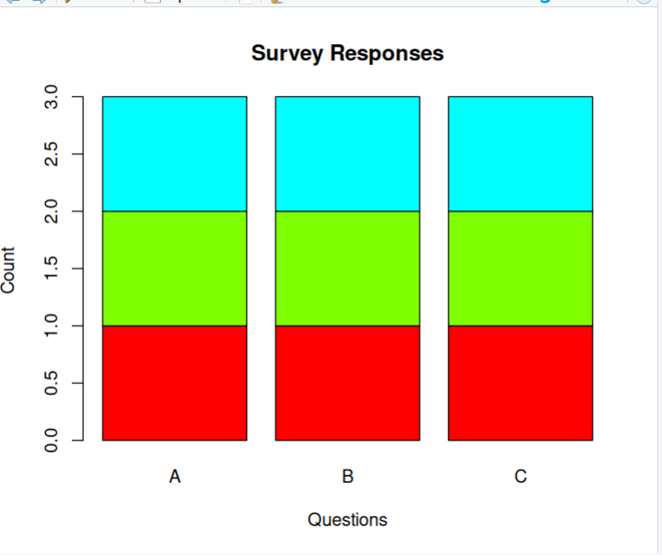

SET 15 – PRODUCT SALES ANALYSIS
product <- c("Product A","Product B","Product C")
jan <- c(2000,1500,1200)
feb <- c(2200,1800,1400)
mar <- c(2400,1600,1100)

sales <- data.frame(
January=jan,
February=feb,
March=mar
)

rownames(sales) <- product

barplot(as.matrix(sales),
beside=TRUE,
col=c("red","green","blue"),
legend=colnames(sales),
main="Quarterly Product Sales",
xlab="Products",
ylab="Sales")

matplot(t(sales),
type="l",
lty=1,
lwd=2,
col=1:3,
xaxt="n",
xlab="Month",
ylab="Sales",
main="Sales Trend")

axis(1,at=1:3,labels=c("Jan","Feb","Mar"))

legend("topleft",
legend=product,
col=1:3,
lty=1)

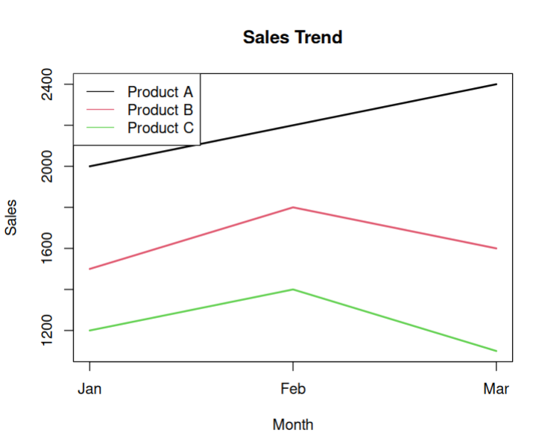
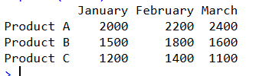
print(sales)

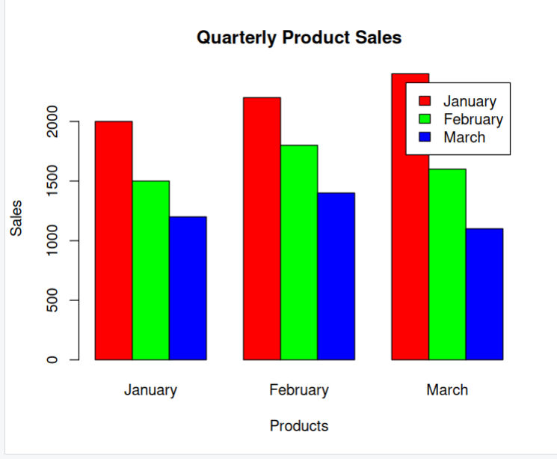

SET 16 – CUSTOMER DEMOGRAPHICS ANALYSIS
customer <- 1:3
age <- c(28,35,42)
gender <- c("Female","Male","Female")
income <- c(50000,60000,75000)

barplot(age,
names.arg=customer,
col="skyblue",
main="Customer Age Distribution",
xlab="Customer ID",
ylab="Age")

pie(table(gender),
col=c("pink","lightblue"),
main="Gender Distribution")

demo <- data.frame(
Customer_ID=customer,
Age=age,
Gender=gender,
Income=income
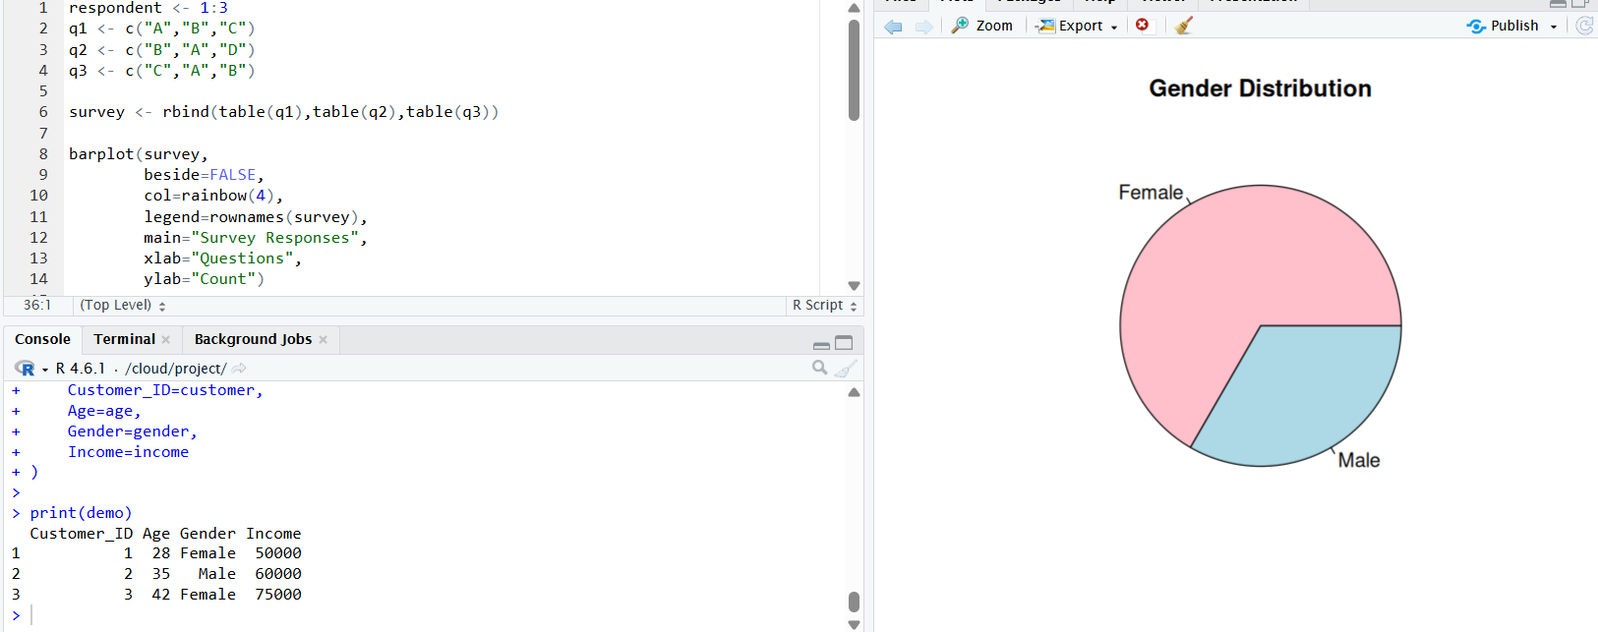
)

print(demo) 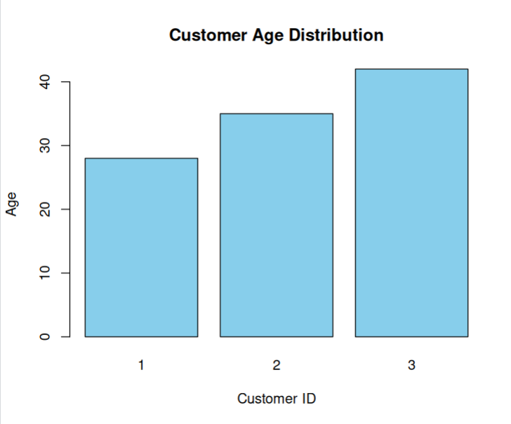

SET 17 – EMPLOYEE PERFORMANCE ANALYSIS
employee <- 1:3
department <- c("Sales","HR","Marketing")
service <- c(5,3,7)
score <- c(85,92,78)

plot(employee,
score,
type="o",
pch=19,
col="blue",
main="Employee Performance",
xlab="Employee ID",
ylab="Performance Score")

barplot(table(department),
col="orange",
main="Department Distribution",
xlab="Department",
ylab="Employees")

performance <- data.frame(
Employee_ID=employee,
Department=department,
Years_of_Service=service,
Performance_Score=score
) 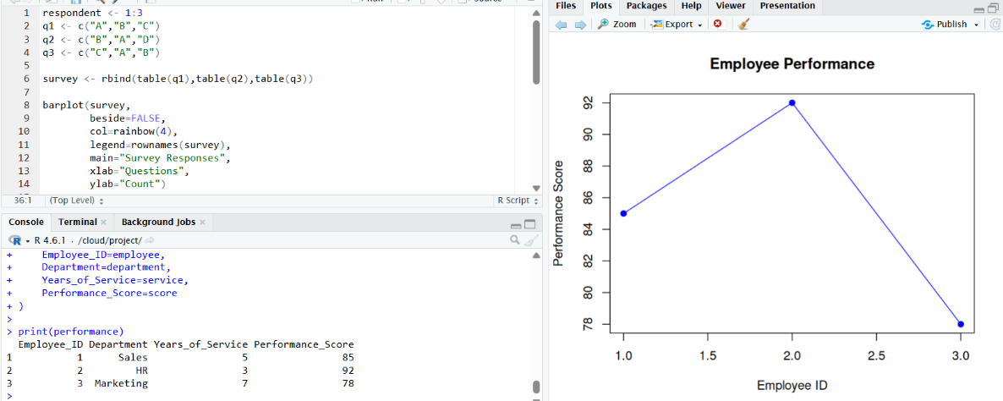

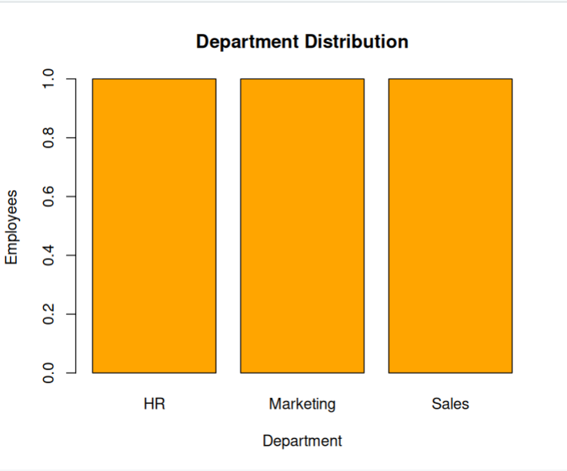
print(performance)

SET 18 – PRODUCT INVENTORY MANAGEMENT
product <- c("Product A","Product B","Product C")
quantity <- c(250,175,300)
price <- c(20,15,18)

barplot(quantity,
names.arg=product,
col="green",
main="Inventory Quantity",
xlab="Products",
ylab="Quantity")

category1 <- c(120,90,150)
category2 <- quantity-category1

inventory <- rbind(category1,category2)

barplot(inventory,
col=c("red","blue"),
legend=c("Category1","Category2"),
main="Stacked Inventory")

inventory_table <- data.frame(
Product=product,
Quantity=quantity,
Price=price
)

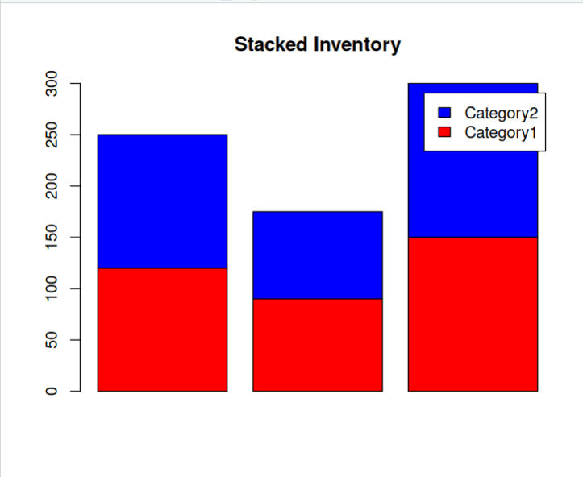
print(inventory_table)
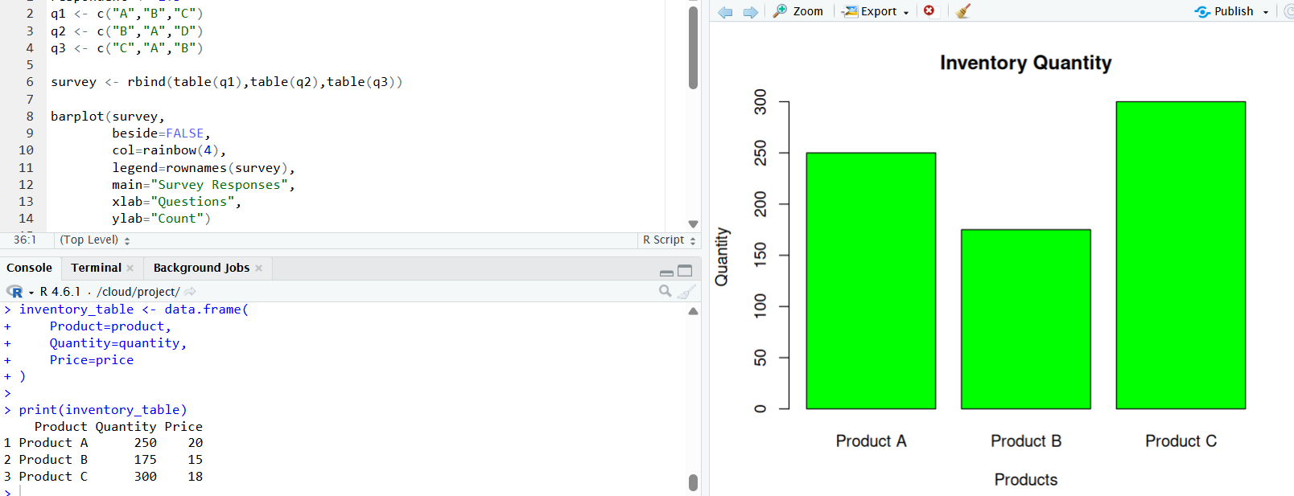

SET 19 – SURVEY RESPONSES ANALYSIS
survey_id <- 1:3
q1 <- c("A","B","C")
q2 <- c("B","A","D")
q3 <- c("C","A","B")

q1_table <- table(q1)

barplot(q1_table,
beside=TRUE,
col="skyblue",
main="Distribution of Question 1 Responses",
xlab="Responses",
ylab="Count")

response_table <- rbind(table(q1),table(q2),table(q3))

barplot(response_table,
beside=FALSE,
col=rainbow(4),
legend=rownames(response_table),
main="Overall Survey Responses")

survey_data <- data.frame(
Survey_ID=survey_id,
Question1=q1,
Question2=q2,
Question3=q3
)

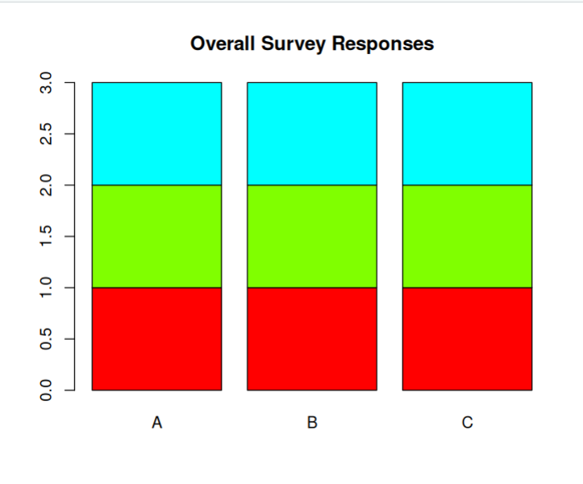
print(survey_data)
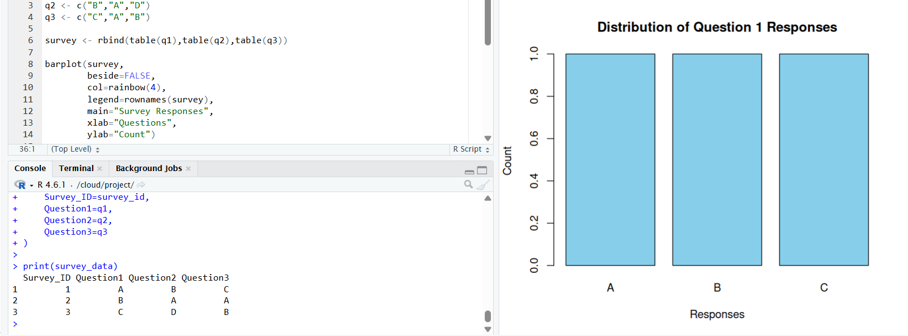
SET 20 – STOCK ANALYSIS
date <- as.Date(c("2023-01-01","2023-01-02","2023-01-03"))

stockA <- c(100,105,110)
stockB <- c(150,152,148)
stockC <- c(120,118,122)

plot(date,
stockA,
type="o",
col="red",
ylim=c(90,160),
xlab="Date",
ylab="Stock Price",
main="Stock Price Analysis")

lines(date,stockB,type="o",col="blue")
lines(date,stockC,type="o",col="green")

legend("topleft",
legend=c("Stock A","Stock B","Stock C"),
col=c("red","blue","green"),
lty=1,
pch=1)

change <- c(0,diff(stockA)/head(stockA,-1)*100)

barplot(change,
names.arg=date,
col="orange",
main="Daily Percentage Change - Stock A",
xlab="Date",
ylab="% Change")

stock_data <- data.frame(
Date=date,
Stock_A=stockA,
Stock_B=stockB,
Stock_C=stockC
)

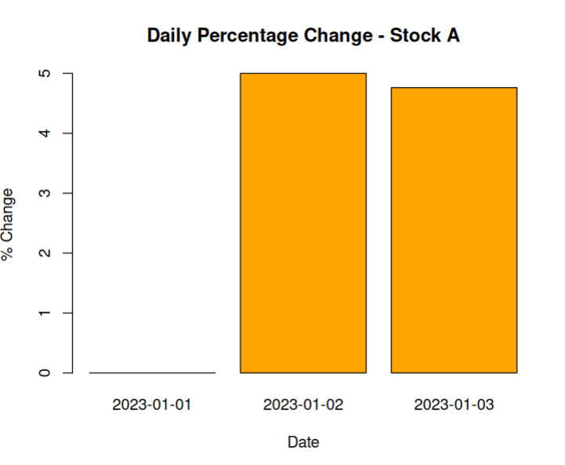
print(stock_data) 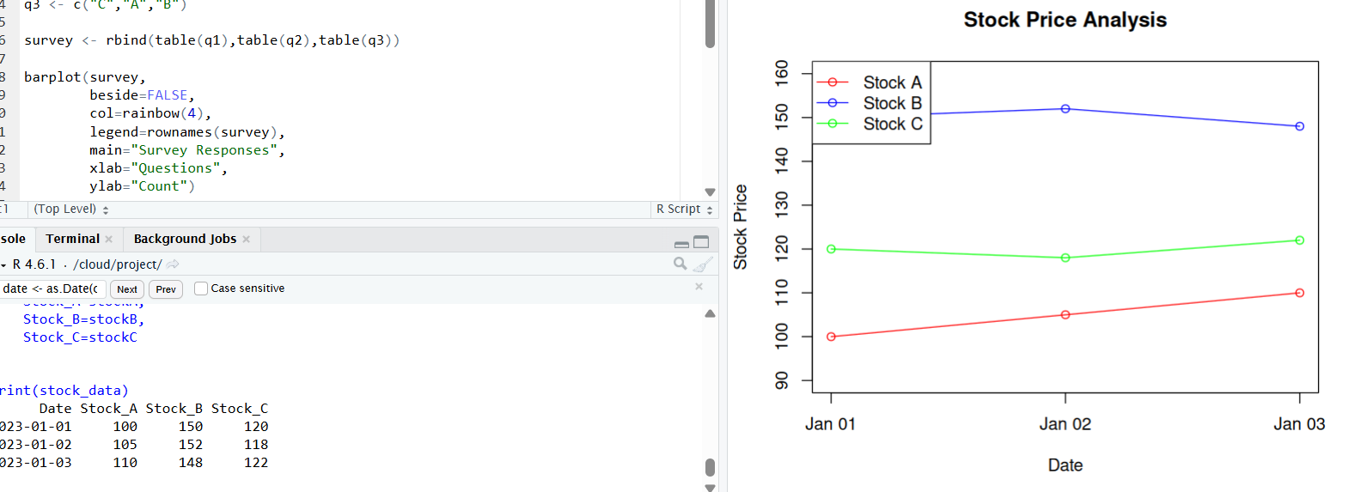

SET 21 – ENERGY CONSUMPTION DATA
sector <- c("Residential","Commercial","Industrial","Residential","Commercial","Industrial")
region <- c("North","South","West","East","North","South")
month <- c("Jan","Jan","Feb","Feb","Mar","Mar")
temperature <- c(15,24,20,18,28,30)
units <- c(320,540,880,350,610,920)
cost <- c(2100,3600,5900,2300,4100,6200)
renewable <- c(22,18,12,25,20,15)
peak <- c(4,6,8,5,7,9)

hist(units,
probability=TRUE,
col="skyblue",
main="Units Consumed",
xlab="Units Consumed")

lines(density(units),col="red",lwd=2)

symbols(temperature,
units,
circles=peak,
inches=0.3,
bg=rgb(0,0,1,0.5),
xlab="Temperature",
ylab="Units Consumed",
main="Temperature vs Units")

avg <- aggregate(renewable,
by=list(sector),
FUN=mean)

barplot(avg$x,
names.arg=avg$Group.1,
col="green",
main="Average Renewable Usage",
xlab="Sector",
ylab="Renewable Usage (%)")

print(avg) 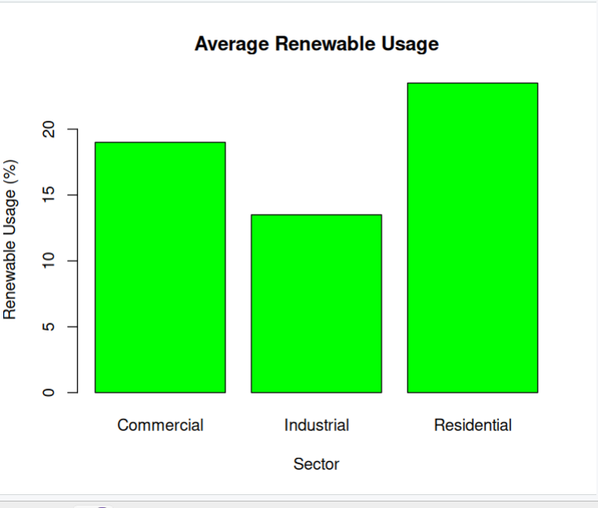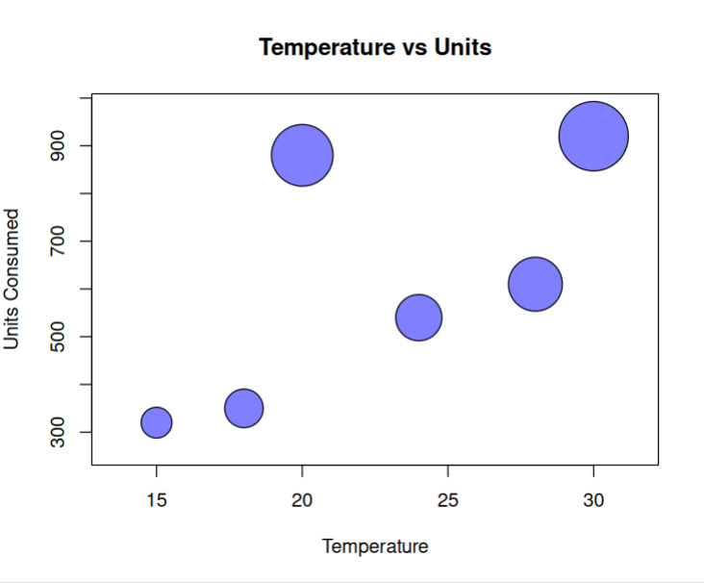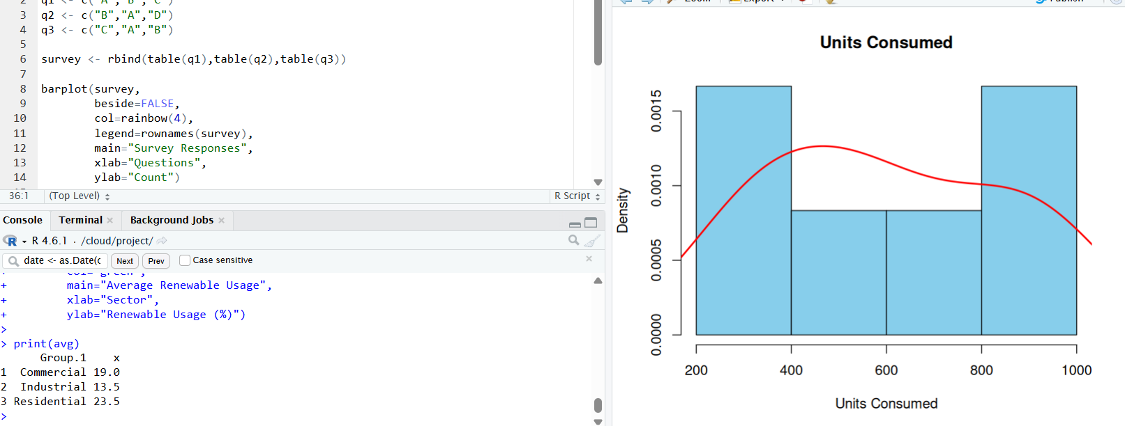

SET 22 – TIME SERIES ANALYSIS
month <- c("January","February","March","April","May")
sales <- c(15000,18000,22000,20000,23000)

ts_sales <- ts(sales,start=1,frequency=12)

plot(ts_sales,
type="o",
col="blue",
xlab="Month",
ylab="Sales",
main="Monthly Sales Trend")

advertising <- c(2000,2500,3000,2800,3200)

plot(advertising,
sales,
pch=19,
col="red",
xlab="Advertising Budget",
ylab="Sales",
main="Advertising Budget vs Sales")

acf(ts_sales,
main="Autocorrelation Plot")

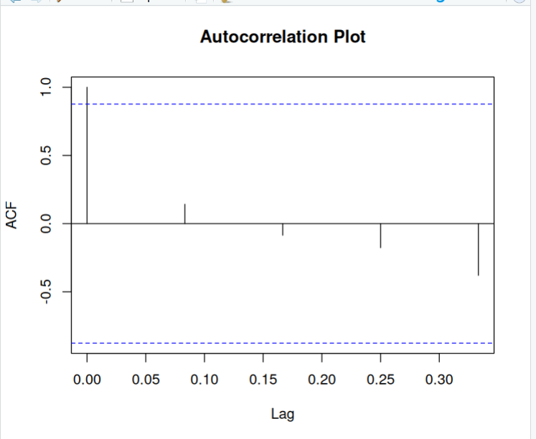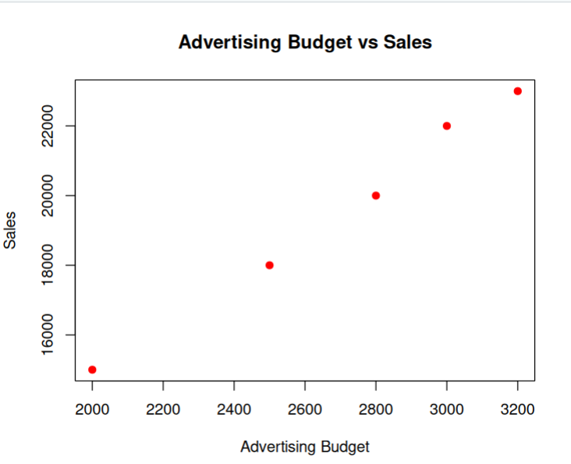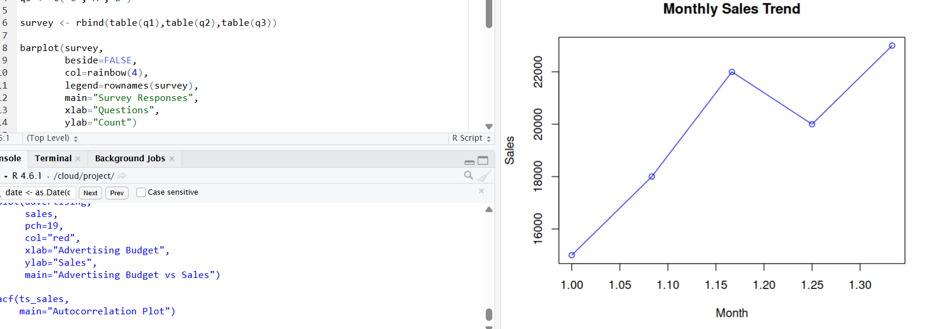

SET 23 – EMPLOYEE PERFORMANCE ANALYSIS
employee <- 1:5
department <- c("Sales","HR","Marketing","Sales","HR")
service <- c(5,3,7,4,2)
score <- c(85,92,78,90,76)

barplot(table(department),
col="orange",
main="Department Distribution",
xlab="Department",
ylab="Employees")

plot(employee,
score,
type="o",
pch=19,
col="blue",
xlab="Employee ID",
ylab="Performance Score",
main="Employee Performance")

performance <- data.frame(
Employee_ID=employee,
Department=department,
Years_of_Service=service,
Performance_Score=score
)

print(performance)
